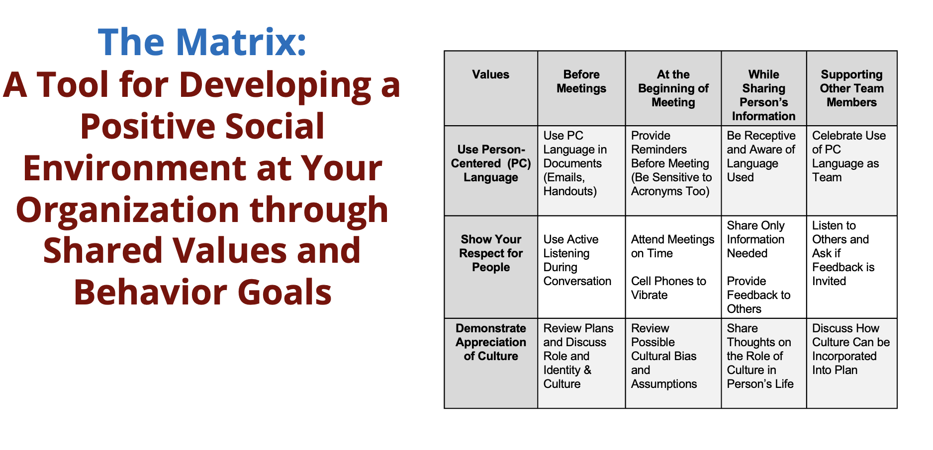

1. Identify stakeholders

2. Each person in your group, generate list of values
Work together to group/narrow these down to 3 to 5

3. Identify a setting (or 2) to focus on
–Good settings/activities may be times when people are interacting together semi-frequently (meetings, “email communications”, dinner, transitions, arrival at a location)

4. Identify how the values you selected translate to behaviors in that setting/activity

Person centered values | Setting 1/ time of day | Setting 2/ time of day | Setting 3/ time of day | Setting 4/ time of day
Value 1

Value 2

Value 3

Person centered values | Setting 1/ time of day | Setting 2/ time of day | Setting 3/ time of day | Setting 4/ time of day
Value 1

Value 2

Value 3

