Learning Support Plan
Person Centered Thinking Coaches
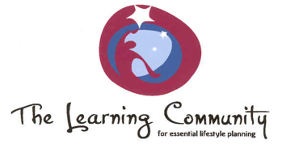
Think about who you would match well with as a support team? Identify two other people by thinking about access to each other, teaching styles, type of work, how you have worked together in the past. Please identify who you will work with as a support team for the next several months:

Where do I have opportunities to practice the new skills? | Who will I practice my skills with? | What gifts do I have that will help me with this? | What support might I need to feel confident in my ability to coach others?

This is how I will know my skills are expanding:

This is how I will know I need support:

Suggestions to coaches: Use the learning log immediately after practicing a tool with a team, so that you are prepared to discuss it at the next Coaches Support Meeting.
Coaches Learning Log
DATE | What tool did you use? What did you do? (What, where, when, how long etc.) | Who was there? (First name of the person, staff, others etc.) | What did you learn about what worked well? What did the person, staff, others like about the activity? What tips do you have for other Coaches? | What did you learn about what didn’t work well? What did the person, staff, others not like about the activity? What will you try differently the next time?

