TIPS for Using the 4 + 1 Questions:

- On separate pieces of paper (flip chart paper is preferred) write at the top the following:
  - Things we have tried.
  - Things we have learned.
  - Things we are pleased about.
  - Things we are concerned about.

Each sheet will look like the following:

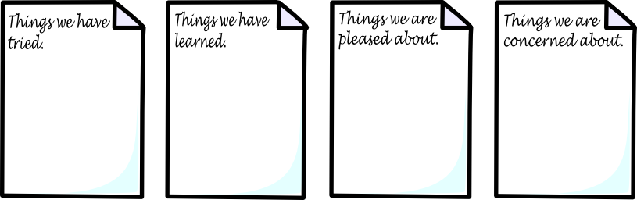

- Tape all sheets on the wall so that everyone can see each sheet.

- Everyone will choose a colored marker to write with. Each person will have a different colored marker to make it easy to identify the different perspectives of each person. OR have everyone use the same color if there is a sense that people would appreciate being anonymous.

- Everyone will write on each paper answering the questions:

“Since we last got together…”
  - Things we have tried.
  - Things we have learned.
  - Things we are pleased about.
  - Things we are concerned about.

- Questions may also involve around things that are more specific like:

  - “Regarding Sally’s new health plan…”
  - “Jon’s experience with activities in the community…”
  - “In learning to communicate better with Angolina…”

- TIPS or guidelines to share with group before people start writing their ideas on paper:

  - No talking or problem solving when everyone is writing.
  - Everyone must be comfortable with writing; people must feel that spelling and grammar do not matter.
  - There are no “Stupid Questions/Answers”.
  - Anyone that feels they cannot write should be supported by having someone write for them.
  - If the person being supported is present, identify a person(s) to assist if needed.

- After everyone has contributed, the team will discuss each idea or input. Clarify where needed and document on the large paper.
- Put up another piece of large paper and title it “Next Steps – What, Who, & By When”.

- The team should then answer the following:

“Based on what we now know, how should we move forward?”

NOTE: The team may decide what new things to try and/or actions to be taken when the team meets again.

