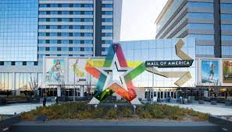

- Go to Metro Transit site on mobile phone.
- Type in starting location (MOA) and destination (Elmer Andersen Building)
- Walk to the Blue Line train platform, toward downtown Mpls.
- Board the Blue Line train
- Transfer at US Bank Stadium to the Green Line (listen for the conductor’s signal)
- Walk to platform that indicates trains heading to downtown St. Paul.
- Board Green Line train
- Exit train at Elmer Andersen building (10th Street - listen for the conductor’s signal)

