This tool can be used to assess how well an organization is implementing person-centered practices and positive behavior support in two different ways: 1) observe staff and/or people being supported in a setting, and 2) as a self-assessment process. Observations may be conducted within a county, public health, or mental health organization to observe changes in staff or within provider organizations to observe changes in behaviors of both staff and people receiving support.

Instructions for Observations: Record your observations of staff and/or people living/working in a setting during a 20-minute period of time. Complete the attached worksheet before starting an observation and review the definitions for each item below before you begin the observation.

Date and Time of Observation: October 9, 2016

Setting Observed: Getting Up in the Morning

Number of People Present During Observation Session:
- Number of Staff Members: __2 Members of Team; One person Observed______________
- Number of People Observed During Session: __One Person Receiving Support Observed_____________

Please gain consent from anyone observed. Please use the following script for people receiving services: We want to do a better job supporting you. We made a list of the things we are learning to do so that we don’t forget to use them. Can we spend time with you today to see if the list we made is helpful for you?
Part 1  Observe staff using the list below.  Person-Centered Behaviors  - Person-First Language  - Nonjudgmental Descriptive Language  - Working in Alliance with the Person  - Reflective Listening Skills  - Person-Centered Thinking  - Demonstrates Empathic Behavior  Subtotal: _____/6 ______%  Promoting Social Engagement & Interactions  - Encouraging Others to Engage in Social Interaction  - Supporting Choices  - Reinforcing Others  Subtotal: _______/3 _______%  Total for Part 1: _______/9 ________% | Part 2  Observe up to two staff members while they are working, or observe people who are receiving services using the list below.  Opportunities to Participate in Positive Social Interactions  - Active Involvement in Conversations/Meetings/Activities  - Engaging in Identified Social Behaviors  Total for Part 2: _______/2 ________%

WORKSHEET INSTRUCTIONS FOR OBSERVATIONS
PURPOSE
The purpose of Part 1 of this tool is to confirm that person-centered strategies are actively used by staff in a particular setting. Part 2 of this observation form is used to confirm that staff members or people living and/or working in a particular setting have opportunities to be actively involved in positive interactions. This tool is intended to be used four times annually.

INSTRUCTIONS
- Identify up to three common activities or settings that occur within an organization where person-centered practices and positive behavior support are implemented and identify them as the setting activity at the top of each section within the preparation form.
- List out the people who are present at each observation and identify those who are being observed by circling them. Include the date of the observation.
- Identify the positive social behaviors for each person being observed using the positive interaction matrix (see Definitions of Each Item on the Minnesota Direct Observation Form for an example of a positive social interaction matrix). The positive social behaviors will be different for each person depending on how they communicate. Providing examples and nonexamples of these behaviors for each person can be helpful for observers to prepare for an observation. Please indicate examples and nonexamples in the Worksheet Preparation Form under “Define Positive Social Behaviors for Person”.
- Before and after an observation, please review the definitions for each of the items on the Observation Form.
- Allocate 20 minutes for each of the three observational settings using a timer or stopwatch to record the time.
- Conduct the observation of the setting and indicate on the MN Direct Observation Form which person-centered and positive behavior support items are present during the observation session.
- Keep a copy of the Worksheet Preparation Form and the MN Direct Observation Form and submit only the MN Direct Observation Form to _________________________.

SETTING 2 ACTIVITY: Getting Up in the Morning

Observation 1:

Date and Time of Observation: October 9, 2016
Names of Staff Present: Lila

Observation 2:

Date and Time of Observation: October 26, 2016
Names of Staff Present: Rhonda

Observation 3:

Date and Time of Observation: November 22, 2016
Names of Staff Present: Lila

Observation 4:

Date and Time of Observation: December 18, 2016
Names of Staff Present: Lila

DEFINE POSITIVE SOCIAL INTERACTIONS FOR THE PERSON:

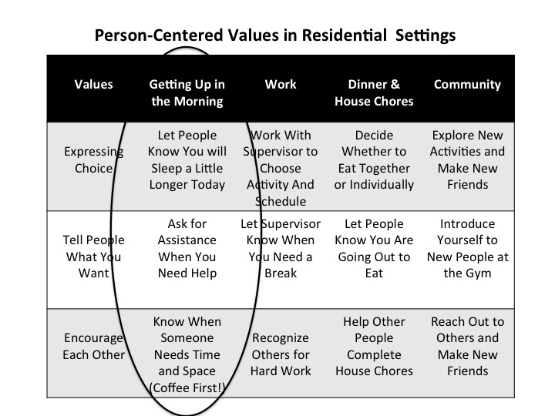

Please define positive social behaviors that each person engages in and write your notes so that observer knows what behaviors to record. Include examples and nonexamples for each of the three people who are observed during the 20-minute period. Examples are included in the section called Definitions of Each Item On the Observation Form. Complete this form for each setting observed.

Name of Person Being Observed Across All Sessions: Ava

Person-Centered Value:  Expressing Choice | Person-Centered Value:  Telling People What You Want | Person-Centered Value:  Encouraging Each Other
Definition:  When the alarm goes off, Ava will let staff know whether she will be getting up or will sleep for another 15 minutes by pushing the snooze alarm button herself. If Ava does not respond to the alarm, Lila will ask Ava whether she wants to sleep longer or start getting ready for the day using Ava’s communication board. Lila may lightly touch Ava’s hand that is closest to the alarm while saying you can hit the snooze button if you want to sleep longer.  Note: active involvement in this activity occurs when Ava turns off the alarm herself or when she talks to staff with her communication board. | Definition:  If Ava has trouble getting dressed for the day because she cannot get her arms or legs into the clothing item, she will turn to Lila and use her communication board to ask for help by pointing to the sign. Ava may also ask for assistance by handing an item to Lila or getting Lila’s attention by pointing to the area that is problematic if it is not easy to use the communication board while getting dressed.  Note: active involvement in this activity occurs when Ava uses the communication board or points to an clothing item while looking at Lila or another staff person. Anytime Ava is looking at Lila or another person, she is actively involved in communicating something to them | Operational Definition:  Ava encourage others when she uses her communication board to say “come sit down and rest”, “do you need some space”, or she pats the seat next to her encouraging another person to sit down and drink coffee with her.  Note: active involvement in this activity occurs when Ava uses the communication board to respond to a person or when she is actively listening to someone. Ava is listening to others when she nods her head or is facing that person with her eyes glancing to the person regularly and then dropping her head for a few seconds to rest.
Examples:  Ava hears the alarm and hits the snooze button two times. Lila quietly lets Ava know that she sees that Ava has made her choice and reminds Ava of the favorite and fun activities she has planned for the day. At the end of the second snooze period, Lila brings reminders of favorite activities Ava has picked out the night before to encourage herself to get up in the morning. | Examples:  Ava turns to Lila and pushes her communication device that says she needs help. Ava holds out her shirt to indicate this is the clothing item she would like Lila to help her with  . | Examples:  Ava sees that Lila looks stressed and points to the communication sign that says “do you need some space?” Lila smiles and says “it was a little crazy at my house this morning.” Ava points to the chair next to her encouraging Lila to sit and enjoy her coffee with her.
Nonexamples:  When Ava does not respond to the alarm, Lila stands by the bed and repeatedly says “time to get up” while pulling at the covers and shaking the bed.  . | Nonexamples:  Ava is frowning and pulling at her shirt. Lila has turned around and is folding clothes and talking to someone in the hallway. | Nonexamples:  Ava is excited to go to work today and hasn’t noticed that her friend, Andrea, who meets her in the morning to go to work looks sad. When Ava repeatedly asks her friend to move faster, Andrea bursts into tears.

